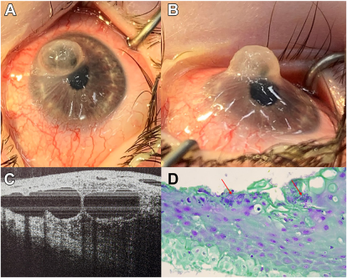

21-month-old with Moebius syndrome presented with parental concern of increased right eye rubbing. The eyes had symmetricmoderate conjunctival injection, with 6-8 mm lagophthalmos bilaterally. Examination under anesthesia revealed a soft eye with shallowanterior chamber, and a 5 4 mm, minimally opaque cystic protuberance in the right nasal cornea that was subtlety Seidel-positive (A, B).Intraoperative OCT demonstrated large cystic fluid cavities throughout the effected corneal stroma, with communication to the anteriorchamber (C). A therapeutic penetrating keratoplasty was performed, and Gram stain of the corneal button as figure (D). Based on the provided images and clinical description please make an ophthalmic diagnosis for this patient. And output the diagnostic conclusions only.

**Right fungal keratitis with microbial keratocyst.**